## Study Area:

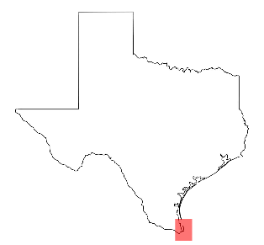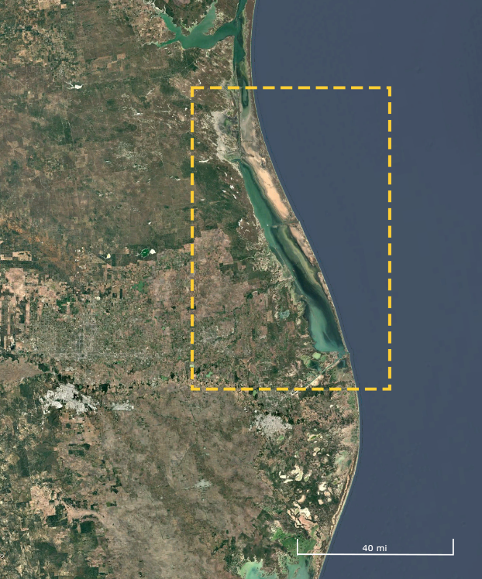South Padre Island is a barrier island in Southern Texas, bordering the Gulf of Mexico. Measuring less than half a mile wide in some places, the barrier island is home to just over 2,000 people and a variety of endangered wildlife as well. Its proximity to the Gulf has been both a blessing and a curse for residents. The coastal environment draws in more than 4 million tourists annually and exposes the residents to danger at the same time.

In recent years, South Padre Island has been hit by numerous hurricanes, ranging from Category 1 storms to Category 4 storms. These cyclones have caused billions in damage to the island’s residents and eroded much of the coastline. Breakwaters are a common solution to problems such as these and have been used across many other barrier islands to reinforce their coastlines.

In this exercise, you will use XBeach to test the performance of a breakwater design against a storm with conditions of your choosing. You will use the batch_transect_empty.m script as a guide, inputting parameters into the specified places. Once it looks like everything is complete, click the “run” button at the top of the screen to see what happens. Good luck!

CSV files with the bathymetry data are located here:

<https://drive.google.com/drive/folders/1f2-Z9URwd0_Xp_QN0474n7Y9s9-RhADX?usp=drive_link>

## Loading and Cleaning Data in MATLAB

1. Open the batch_transect_empty.m script in MATLAB R2024a and load the withbreakwater.csv file or the nobreakwater.csv file.
2. Assign POINT_X to x1, POINT_Y to y1, and grid_code to z1.
3. Use meshgrid to reconstitute the grid, and interpolate z1 with griddata using the 'cubic' option.
4. Plot the bathymetry. You will use the figure it produces to identify where your transects should go.

## Visualizing Transects

1. Define a key list for transects and a structure of their endpoints.
2. Plot the model bed using pcolor and overlay each transect.
3. Save the plot as a PNG file for later reference.

## Generating Input Files for XBeach

1. Loop through each transect.
2. Use linspace to generate evenly spaced x and y points between start and end.
3. Use interp2 to project elevation values onto the transect.
4. Plot the transect profile.
5. Create a folder named after the transect and save the profile image inside.
6. Define the simulation parameters, call create_jonswap.m, run xb_grid_xgrid, write the parameter file, copy xbeach.exe and netcdf.dll into the folder, and start the simulation.

* Where are the waves coming from? What would be an appropriate angle?
* How much storm surge is appropriate? Severe storms might be around 3-4 meters, less intense storms 0-2. This is up to personal preference.
* What significant wave height do you want? For this instance, it will be personal preference. Normally you would look online for this data.

## Running Multiple Simulations

1. Run multiple simulations in parallel—XBeach uses ~11% GPU, so up to 9 can run simultaneously with no slowdowns (depending on computer specs- use smaller batches as needed).
2. Test the setup with up to 3 simultaneous runs to confirm no performance drop (for now).
3. Repeat simulations with the other bathymetry file that you did not use the first time. Make sure to move the folders for each transect to a new location so they won’t be overwritten. Then, put all of the outputs into QUICKPLOT to compare.

## Analyzing Results

1. Let XBeach output NetCDF files containing water level, depth, wave height, and bed level over 2 hours, recorded every minute.
2. Use QUICKPLOT (\QUICKPLOT\bin\d3d.qp) to animate water behavior and compare performance across interventions.